# **11 Oracle Networks – Concepts**

These networks play a crucial role in establishing connections, transmitting data, and managing database access.  
  
**Listener:**  
The Oracle Listener is a process that runs on the database server and listens for incoming connection requests. It acts as a mediator between clients and the database instance.

**TNS (Transparent Network Substrate) Names:**  
TNS names are a naming method used by Oracle to identify the network location and service names for database connections. These names are typically stored in a tnsnames.ora file, which acts as a local repository for resolving service names to network addresses.

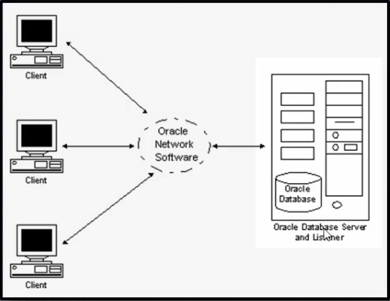

* **DATABASE 🡺 LISTENER 🡺 ORACLE CLIENT 🡺 APPLICATION**

**LISTENER: in database**

**TNS: application team**

* we can create listener & tns manually.
* Using netca utility also we can configure or delete listener or tns.

**LISTENER:**

* Listener should be up & run 24/7. Then application team can connect to the database in any point of time.
* Listener is mainly responsible for taking new connections.
* When the user is connected to database and listener is stopped there will be no impact for user connected. But if new connection cannot establish.

**LISTENER / TNS default location:**

* cd $ORACLE_HOME/network/admin

**To create listener other than default location:**

* add this in ENV file
* export TNS_ADMIN=/location/where/we/want
* Execute file = . Hyd.env

**To start listener: mouli**

* lsnrctl start mouli

**To stop listener: mouli**

* lsnrctl stop mouli

**To check listener status: mouli**

* lsnrctl status

**To check tnsping : pytest**

* tnsping PYTEST

**To connect remote database with sys user we need password file.**

* sqlplus sys/sys123@abc as sysdba

**Listener are two types:**

1. **static listener**

* Irrespective of database status it up and run 24/7.
* In static listener it contain database name.
* We can connect to remote database with sys user when database is in down state.

1. **Dynamic listener**

* It work only when database is in open state.
* This listener is having default configuration (Like default name(LISTENER)&port(1521).
* It will not contain database name.
* Database should register with listener.

**STATIC LISTENER FOR PYTEST**

* SID_LIST_LISTENER =

(SID_LIST =

(SID_DESC =

(GLOBAL_DBNAME = PYTEST)

(ORACLE_HOME = D:\APP\product\11.2.0\dbhome_1)

(SID_NAME = PYTEST)

)

)

LISTENER =

(DESCRIPTION_LIST =

(DESCRIPTION =

(ADDRESS = (PROTOCOL = TCP)(HOST = 10.200.2.14)(PORT = 1521))

)

(DESCRIPTION =

(ADDRESS = (PROTOCOL = IPC)(KEY = EXTPROC1521))

)

)

ADR_BASE_LISTENER = D:\APP

**STATIC TNSNAMES FOR PYTEST**

* PYTEST =

(DESCRIPTION =

(ADDRESS_LIST =

(ADDRESS = (PROTOCOL = TCP)(HOST = 10.200.2.14)(PORT = 1521))

)

(CONNECT_DATA =

(SERVICE_NAME = PYTEST)

)

)

**DYNAMIC LISTENER:**

* LIS_KGKDB = (DESCRIPTION = (ADDRESS = (HOST = EIS2APPT) (PORT = 1522)(PROTOCOL = TCP)))
* register local_parameter
* show parameter local
* alter system set local_listener=‘192.168.1.10:1524/Pune’;
* Alter system register;
* In 11g **PMON** is responsible for regestring database with listener.
* From 12c new background process **LREG** is responsible for regestring database with listener.

**DYNAMIC TNSNAMES:**

* KGKDB= (DESCRIPTION = (ADDRESS = (HOST = EIS2APPT) (PORT = 1522)(PROTOCOL = TCP))(connect_data=(service_name=KGKDB)))